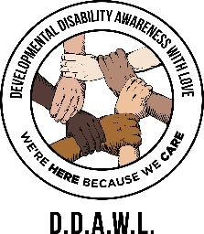
DECEMBER 2025
After Hours Events Calendar
Sunday | Monday | Tuesday | Wednesday | Thursday | Friday | Saturday
 | 1 | 2 | 3 | 4 | 5 | 6
7 | 8 | 9 | 10 | 11 | 12 |   13  MAGIC OF LIGHTS  PNC arts center, Holmdel  3:30pm-8pm  $30 or 18 units
14 | 15 | 16 |   17  KARAOKE  6pm-8pm      $10 or 8 units | 18 | 19 | 20  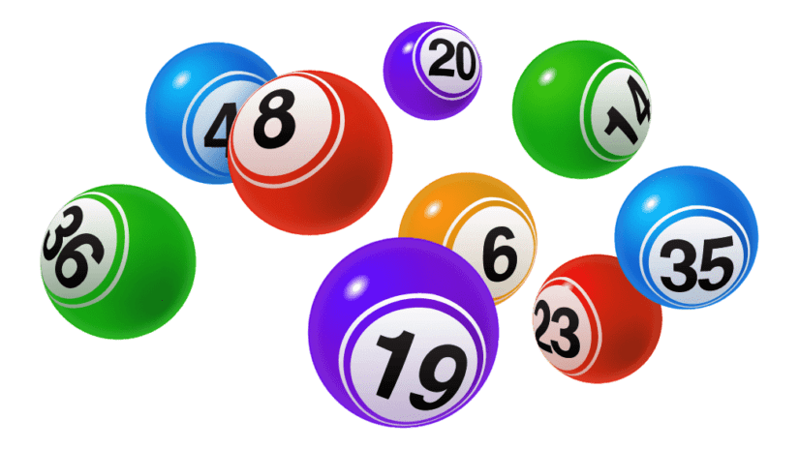    BINGO & CRAFTS    1pm-4pm  $30 or 12 units
21 | 22 | 23 | 24  MERRY CHRISTMAS ------ DDAWL IS CLOSED | 25 | 26 | 27
28 | 29 | 30 | 31
FOR MORE INFORMATION AND TO REGISTER FOR EVENTS PLEASE CONTACT REBECCA HARVEY AT 973-588-5370 EXT. 2,
EMAIL rharvey@ddawl.com OR VISIT DDAWL.COM

DECEMBER 2025
After Hours Events Calendar

12/13/25 Saturday MAGIC OF LIGHTS 3:30 PM – 8:00 PM
WHERE: PNC Bank Arts Center, 116 Garden State Pkwy, Holmdel NJ 07733
WHAT: Meet at DDAWL at 3:30pm and climb aboard the DDAWL “Christmas Express”. We will depart at 4:00p. There will be caroling and Christmas stories as we head to the famous PNC Bank Arts Center dazzling light show, where we will drive through over a mile of spectacular displays (PLEASE BE AWARE THAT THERE MAY BE ANIMATED AND TWINKLING LIGHTS). We plan to return to DDAWL at 8:00p for pick up.
COST: $30 or 18 units

12/17/25 Wednesday KARAOKE 6:00 PM – 8:00 PM
WHERE: DDAWL, 334 W. Main St, Boonton NJ 07005
WHAT: Come sing along to your favorite songs!
COST: $10 or 8 units

12/20/25 Saturday BINGO & CRAFTS 1:00 PM – 4:00 PM
WHERE: DDAWL, 334 W. Main St, Boonton NJ 07005
WHAT: Play Bingo, Get Bingo, Win Prizes, and enjoy the wit and charm of your favorite duo, Marisa and Becki! Then stay and make a Christmas craft sure to brighten your holidays!
COST: $30 or 12 units

